Q1.
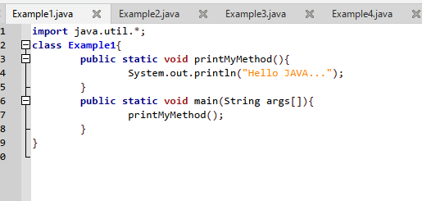

Output.

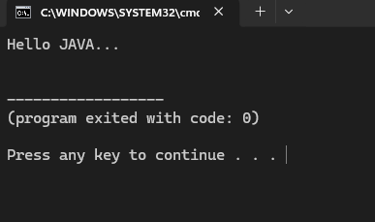

Q2.
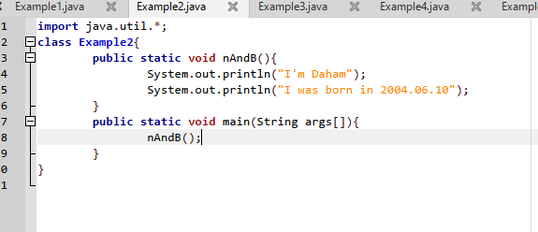

Output.

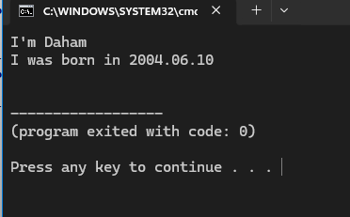

Q3.
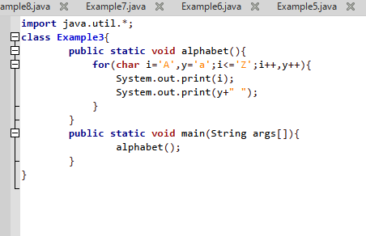

Output.
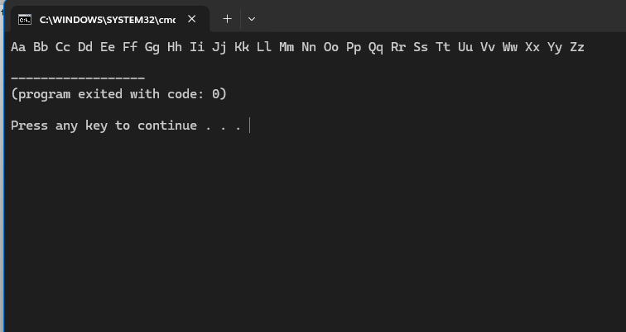

Q4.
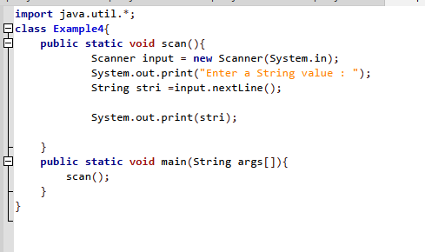
Output.
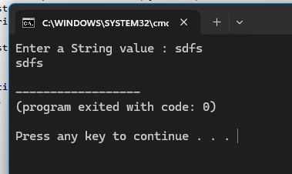

Q5.
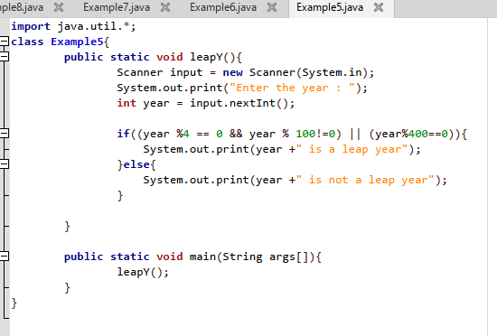
Output.
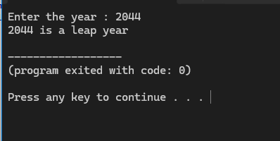

Q6.
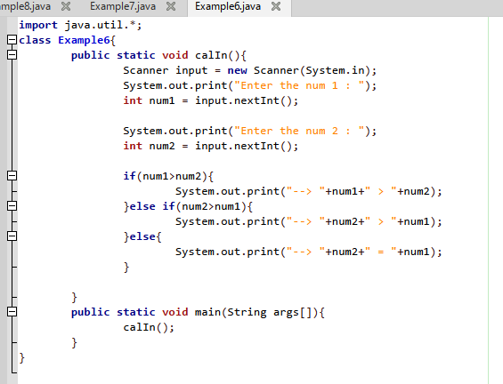
Output.
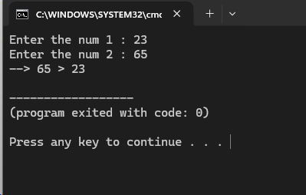

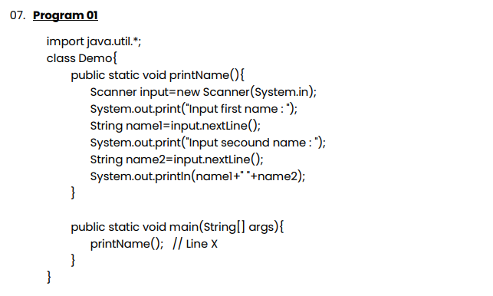
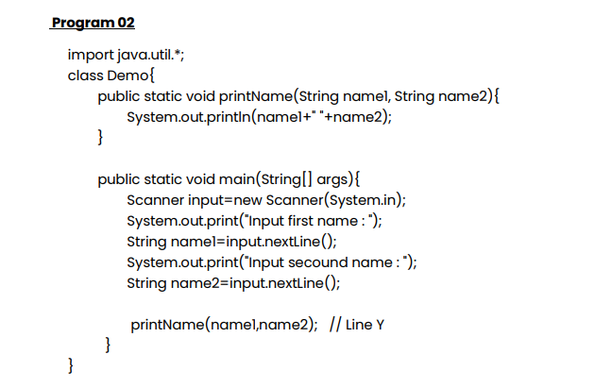

Answer-
In first program it program is running in printName() method, and it calls in main() method.
But in second program some part of program run in main method and another part runs in printName() method, so that 2nd one has parameters and it also calls in main() method.
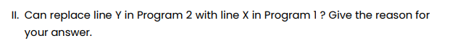
Answer –
No,
Because of running Scanner in main method in program 2, we have to link methods by parameters and arguments ,Without arguments in main method, we cant run printName() method.

Q8.
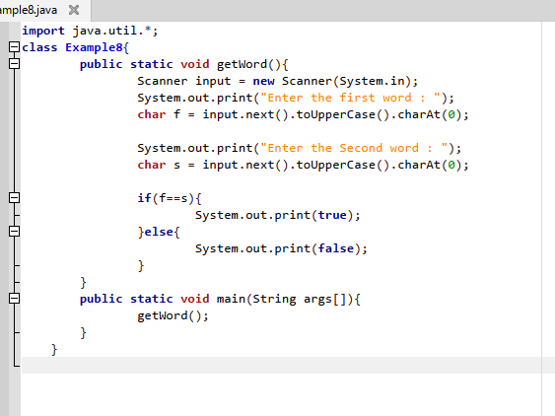
Outputs.
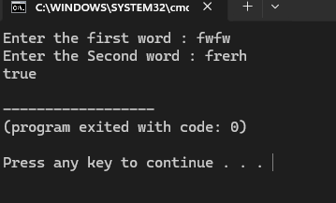
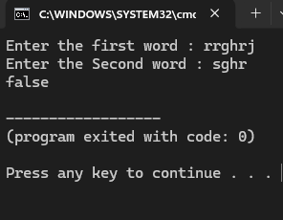

Q9.
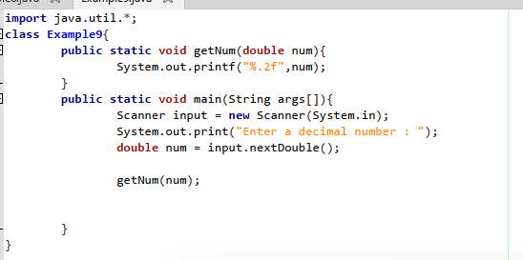

Output.
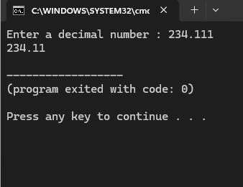

Q10.
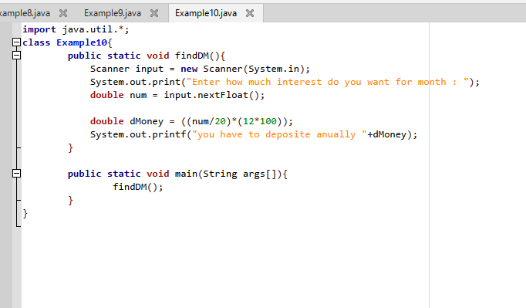

Output.
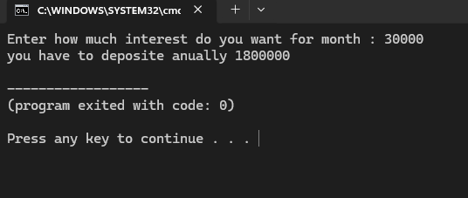

Q11.
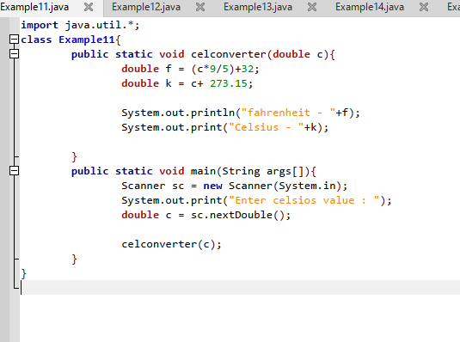
Output.
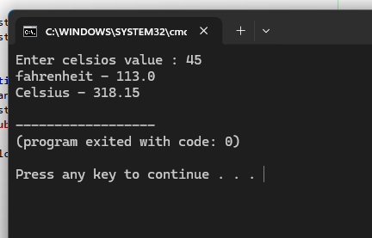

Q12.
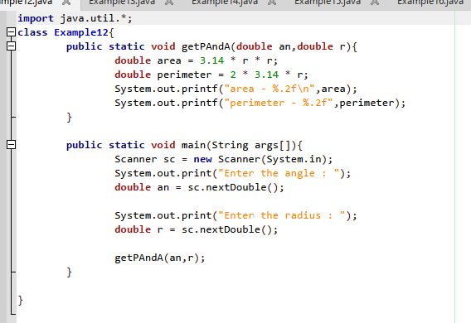
Output.
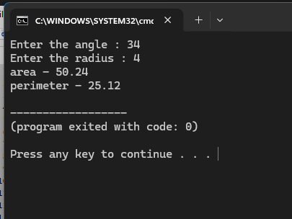

Q14.
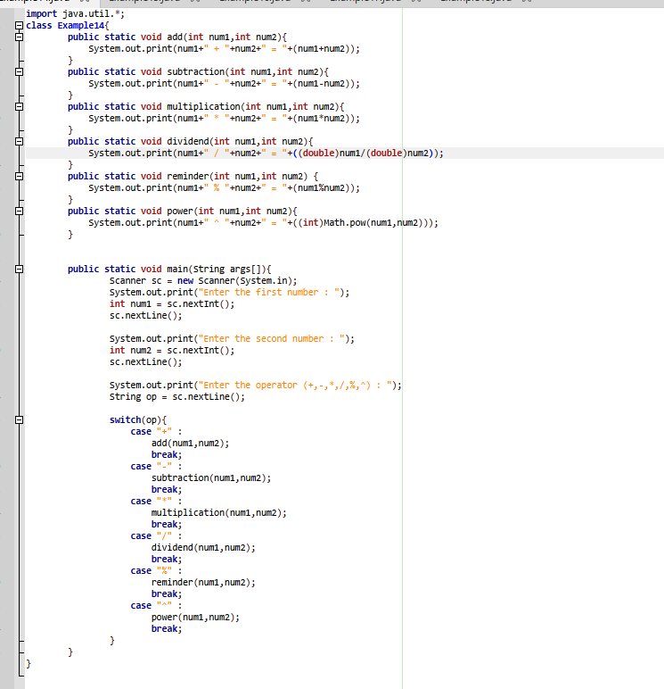

Outputs.
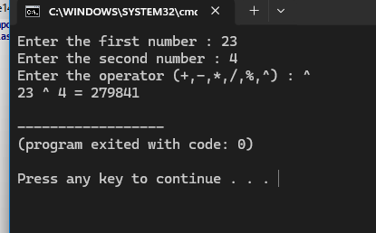
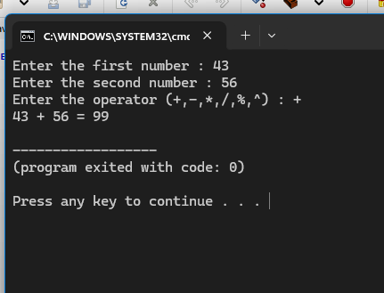
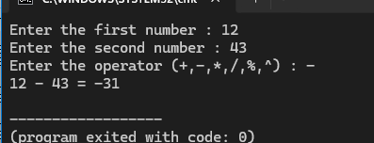
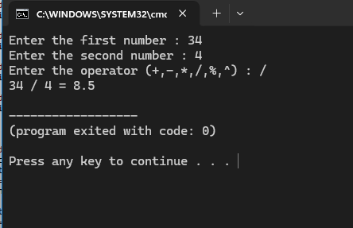
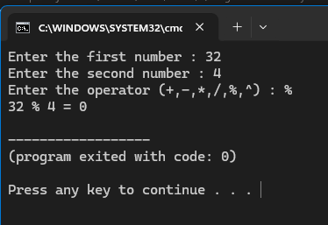
Q15.
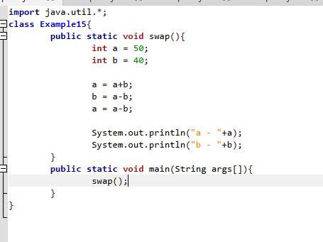

Output.
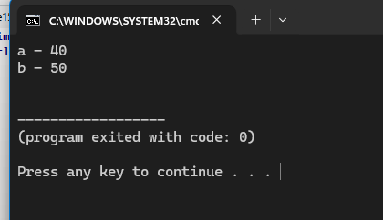

Q16.
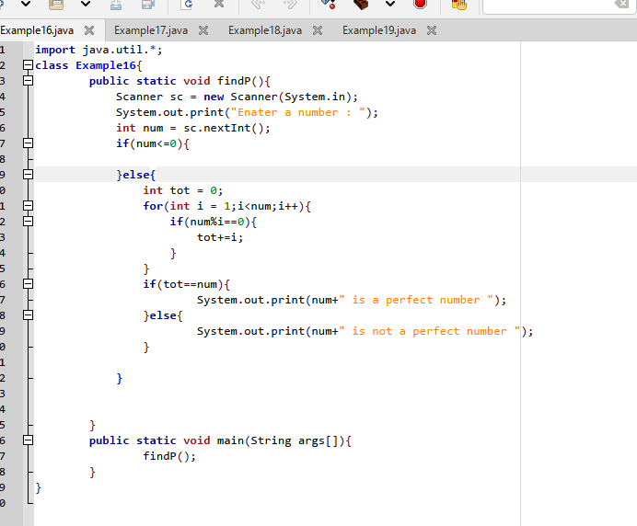

Output.
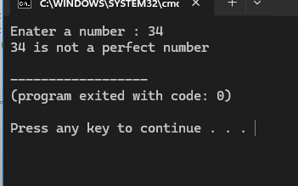
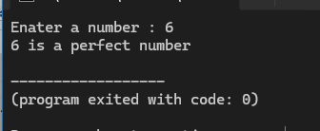
Q17.
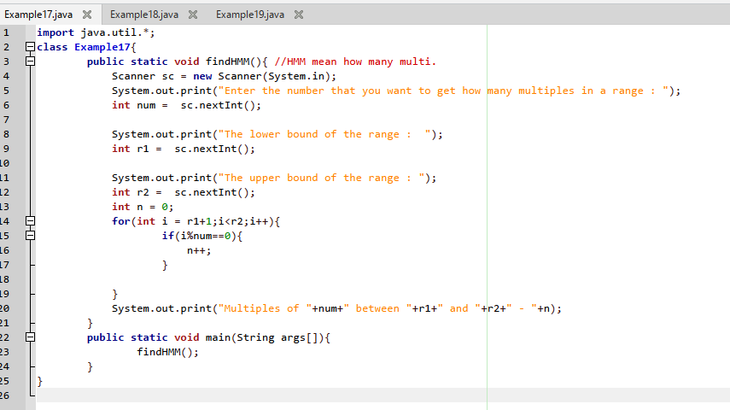

Output.
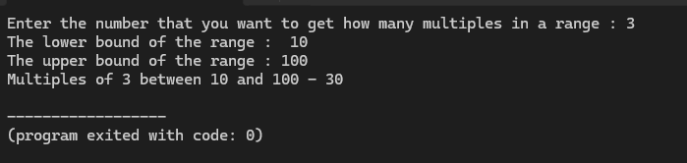

Q18.
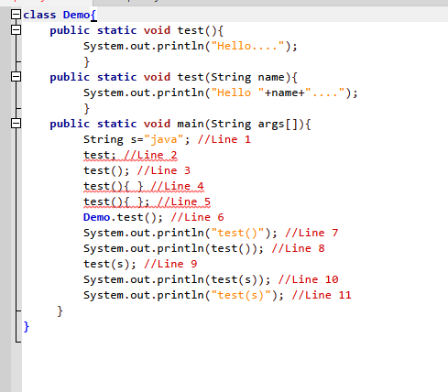
Answers:
line 1 – legal
* Standard String variable declaration and initialization.
line 2 – illegal
* Parentheses () are required when invoking/calling a method.
line 3 – legal
* Correct syntax for calling a static method with no arguments.
line 4 – illegal
* You cannot declare or define a method inside another method block (such as main).
line 5 – illegal
* Same as Line 4; method definitions are not allowed inside main.
line 6 – legal
* Valid static method invocation syntax (assuming a Demo class with a static test() method exists in the same package).
line 7 – legal
* Treats "test()" as a plain String literal inside quotes and prints it directly.
line 8 – illegal
* test() is a void method, meaning it returns nothing. You cannot pass a void method call as an argument to System.out.println().
line 9 – legal
* Correct syntax for calling the overloaded method test(String name) passing s as an argument.
line 10 – illegal
* test(s) is also a void method and has no return value to pass into System.out.println().
line 11 – legal
* Treats "test(s)" as a plain String literal inside quotes and prints it directly.
Q19.
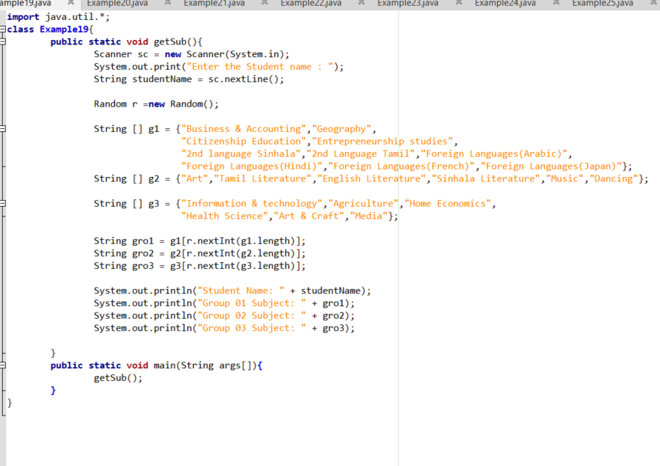
Output.
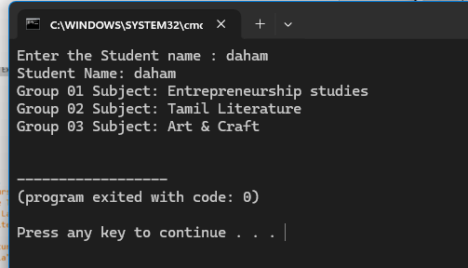

Q20.
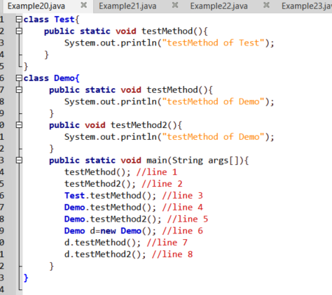
Answer.
Line 2 and Line 5 - compile error because testMethod2()/Demo.testMethod2 are non static, and static method can’t be directly call non static methods.

Q21.
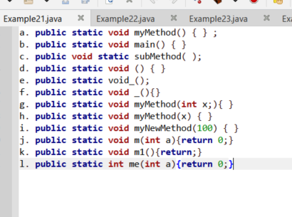
Answers.
- Legal
- Legal
- Illegal
* method body { } is missing
d. Illegal
* missing method identifier(name)
e. Illegal
* method body { } is missing
f. legal
g. Illegal
* we can’t use semicolons when passing parameters
h. Illegal
* Missing data type for parameter( x )
I. illegal
* Missing data type and variable name
j. illegal
k. illegal
* without condition it was illegal
l. legal

Q22.
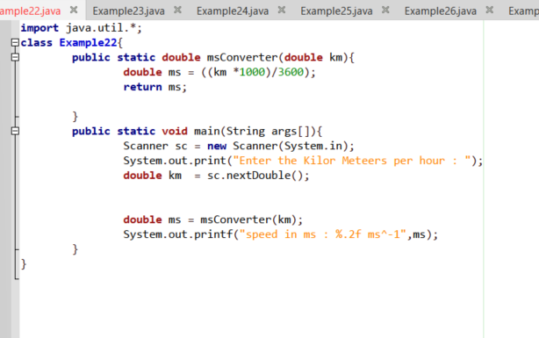
Output.
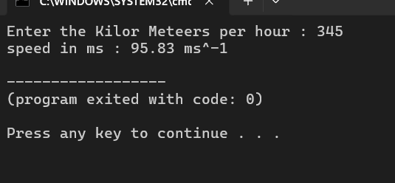

Q23.
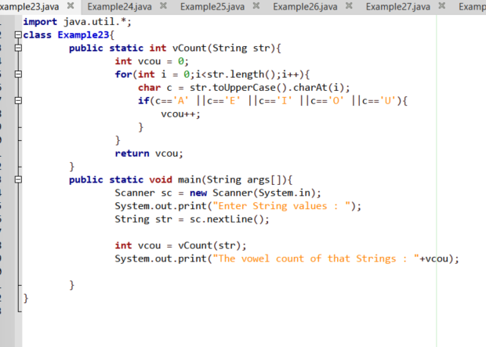
Output.
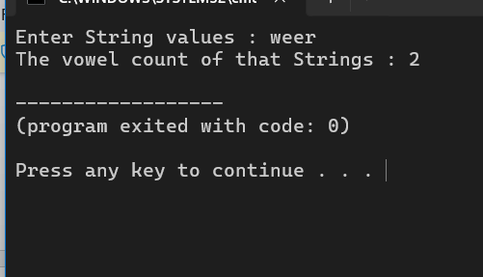

Q24.
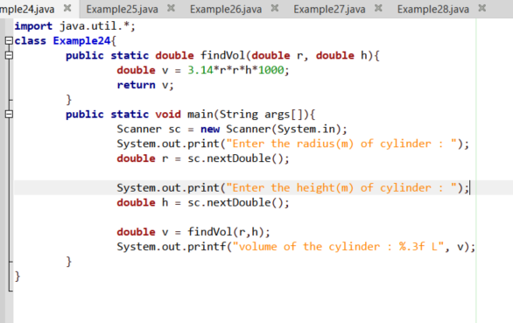
Output.
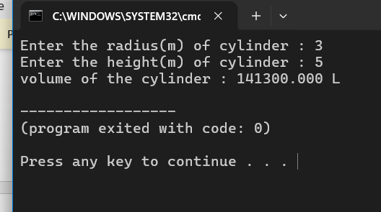

Q25.
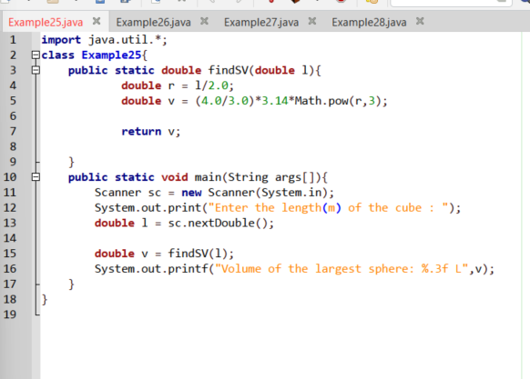
Output.
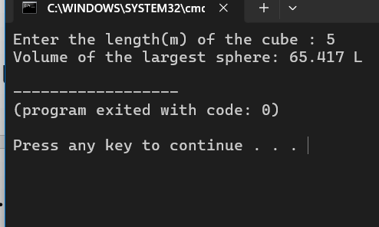

Q26.
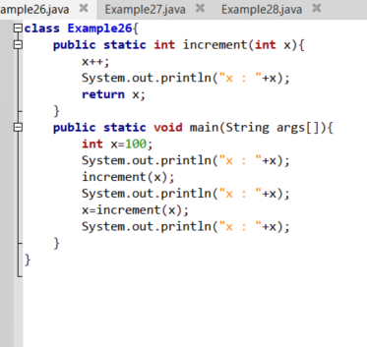
Output.
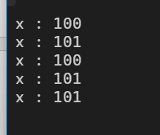

Explain .

System.out.println("x: " + x); (Line 1)
- In the main method, x is initialized to 100.
- Output: x: 100
increment(x); (Line 2)
- The value of x (100) is passed into the increment method.
- Inside increment, x++ increases the local variable x to 101.
- System.out.println("x: " + x); inside the method executes.
- Output: x: 101
System.out.println("x: " + x); (Line 3)
- In Java, primitive data types are passed by value. Changes made to x inside the increment method do not affect the original variable x in the main method.
- Therefore, x in main remains 100.
- Output: x: 100
x = increment(x); (Line 4)
- The increment(x) method is called again, printing x: 101 from inside the method. (Output: x: 101)
- This time, the returned value (101) is reassigned back to x in the main method (x = ...).
System.out.println("x: " + x); (Line 5)
- Now x in main has been updated to 101.
- Output: x: 101

Q27.
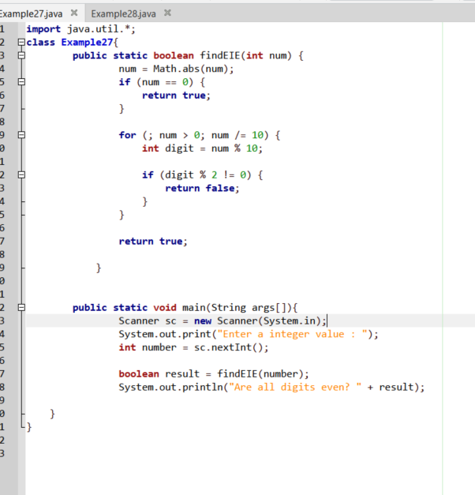

Output.
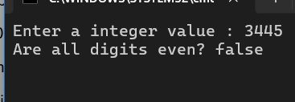
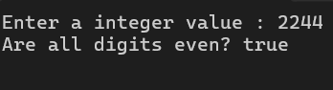

Q28.
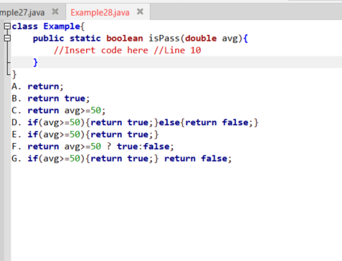
Answers
B,C,D,G

Q29.
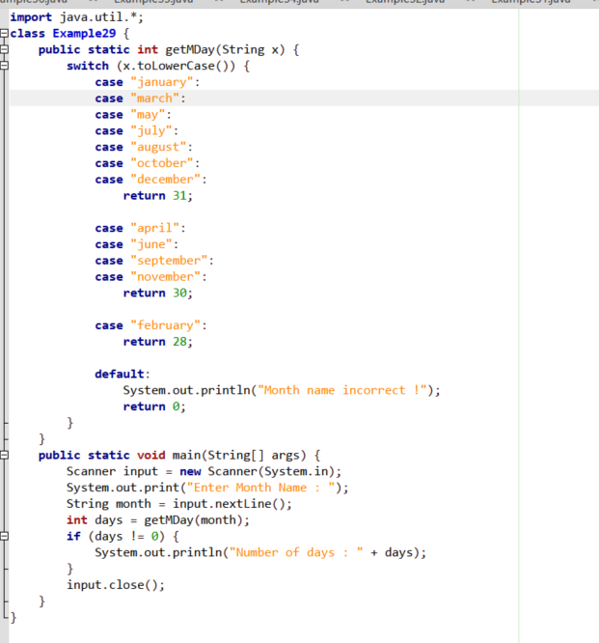
Output.
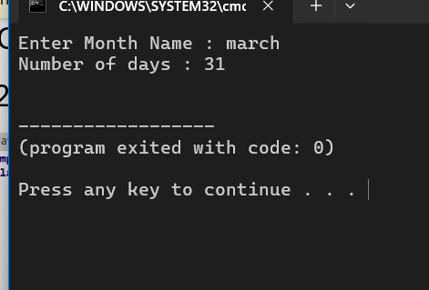

Q30.
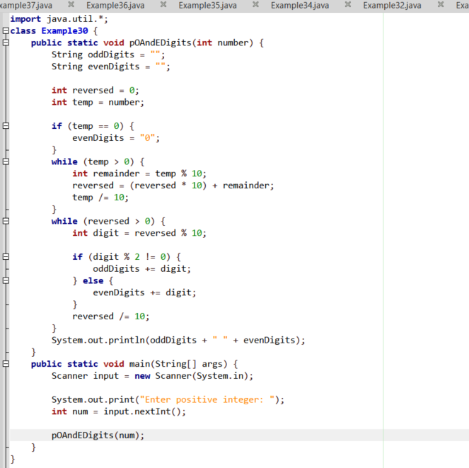
Output.
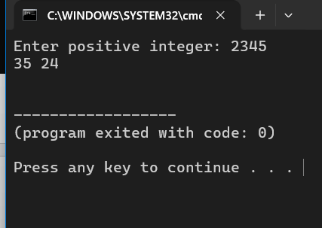

Q31.
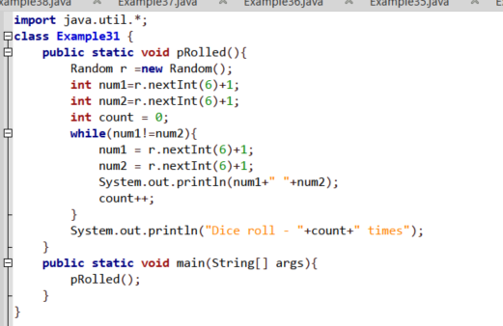
Output.
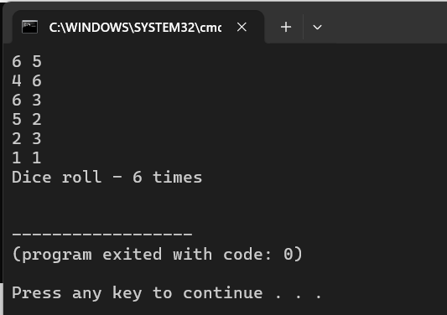

Q32.

Line 1 can inserted A,B,C,G
and line2 can inserted A,B,C,E,G

Q33.
Answers
C,D,E,F,H,K,O

Q34.
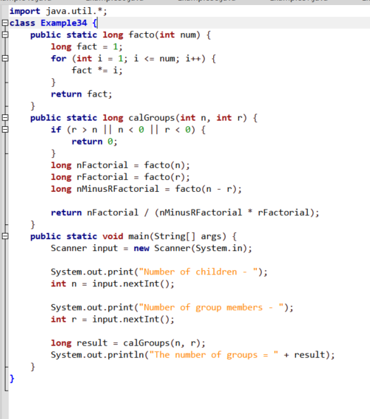
Output.
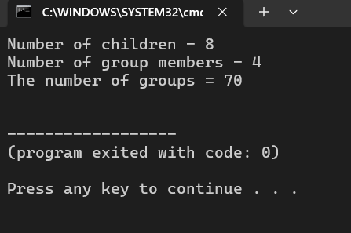
Q35.
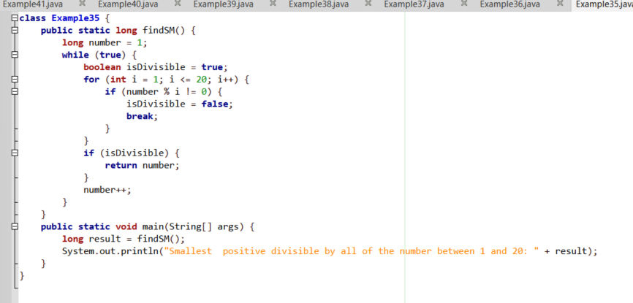
Output.
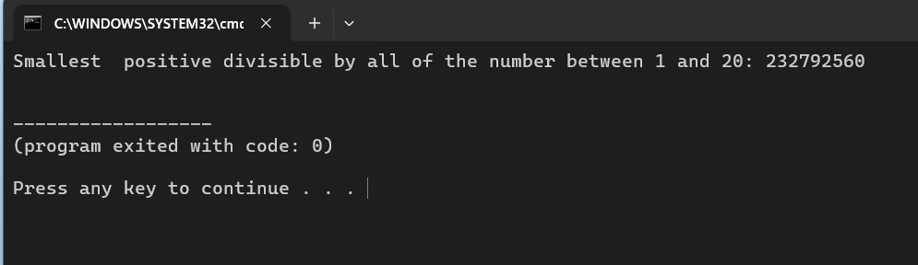

Q36.
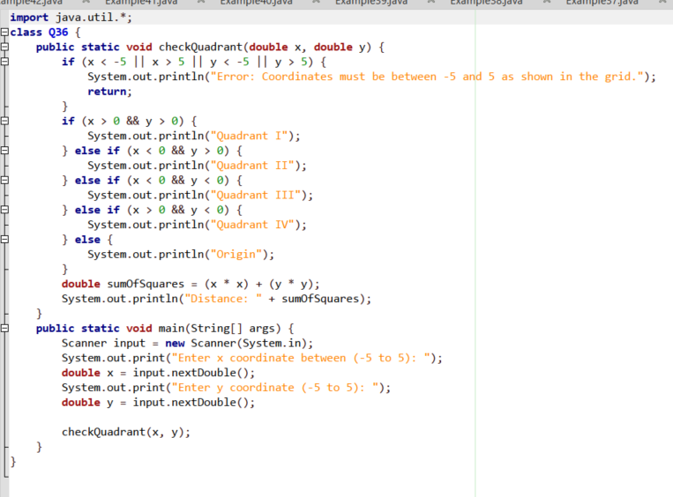
Output.
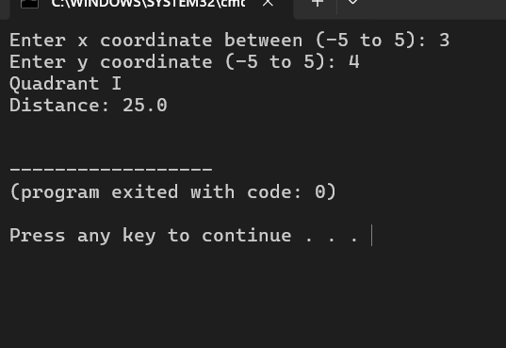
Q37.
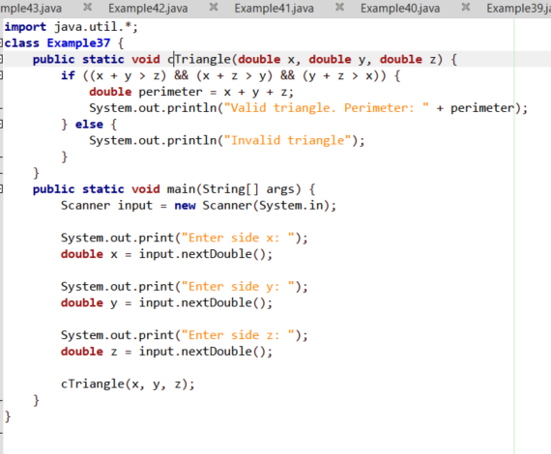
Output.
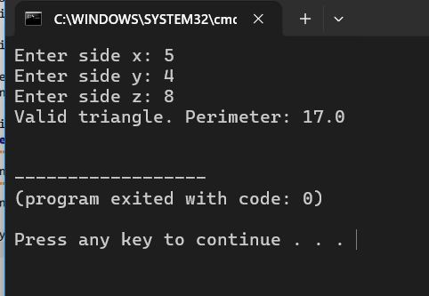

Q38.
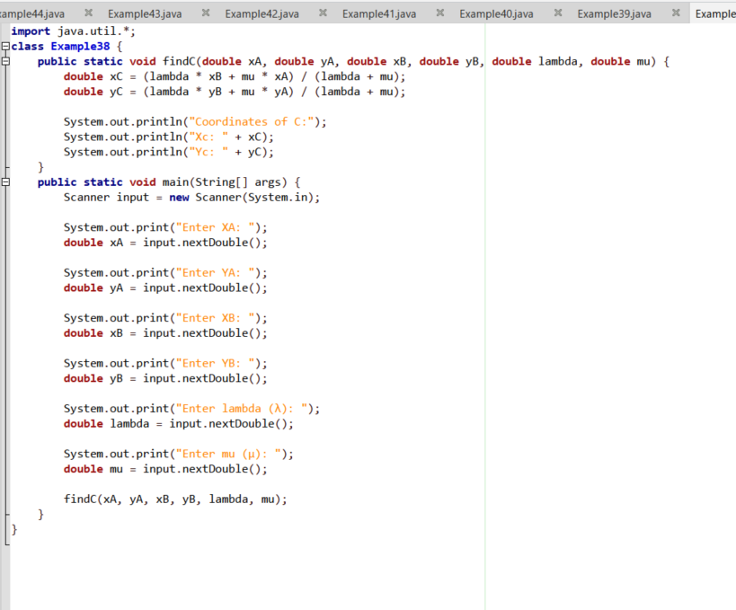
Output.
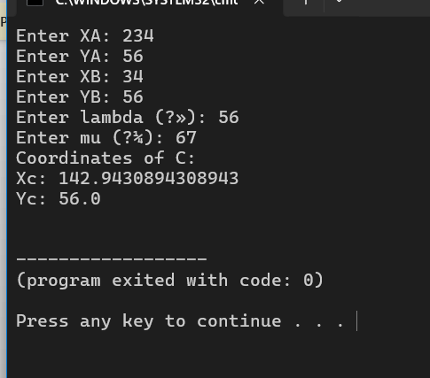

Q39.
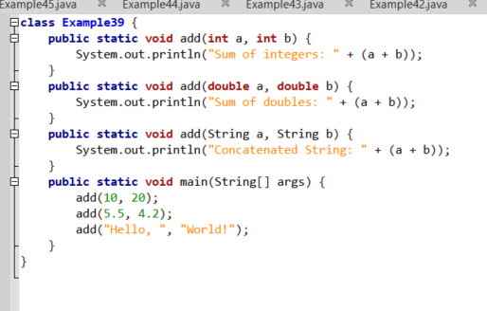
Output.
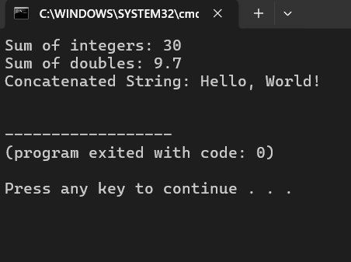

Q40.
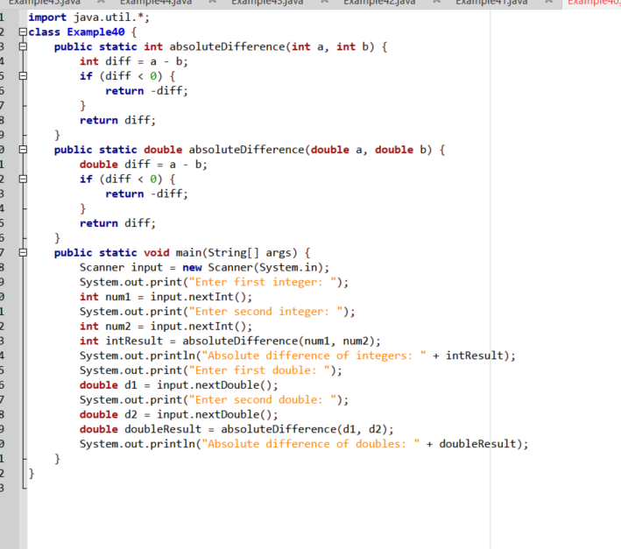
Output.
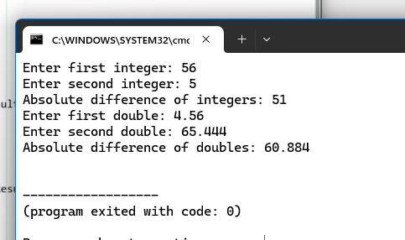
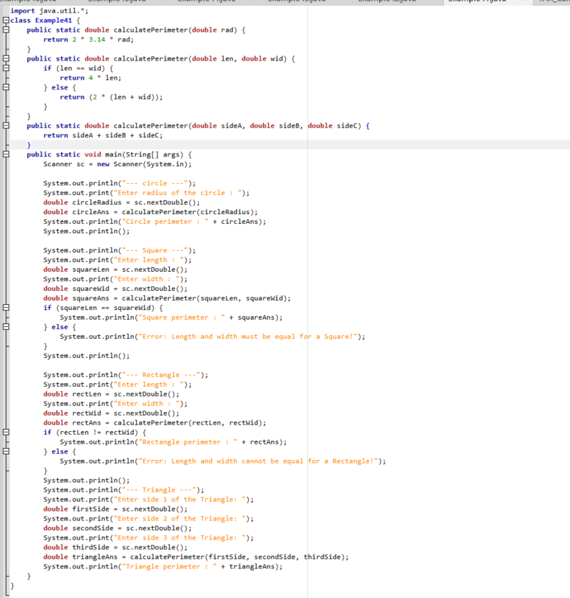
Q41.

Output.

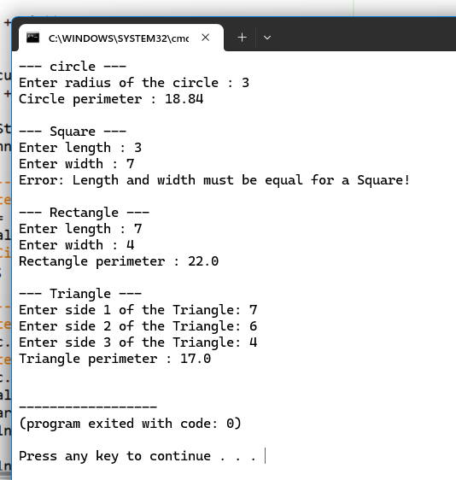
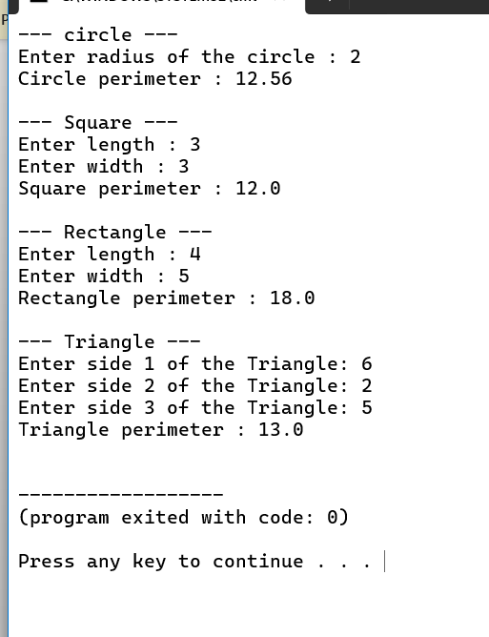
Q42.
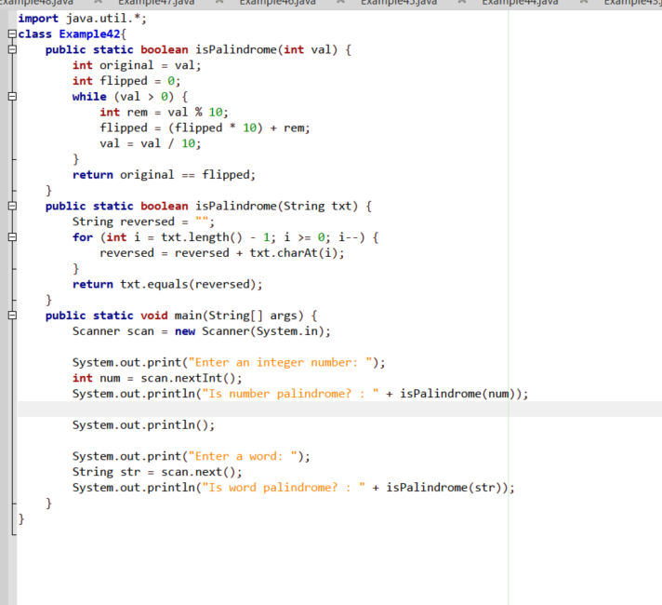
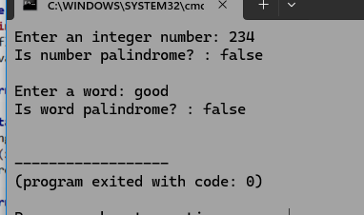
Output.
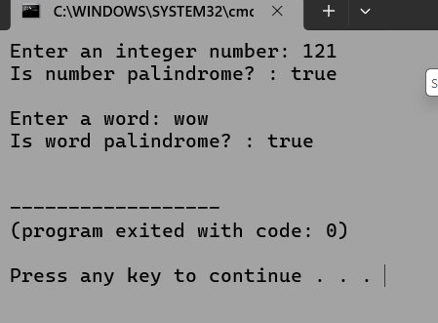

Q43.
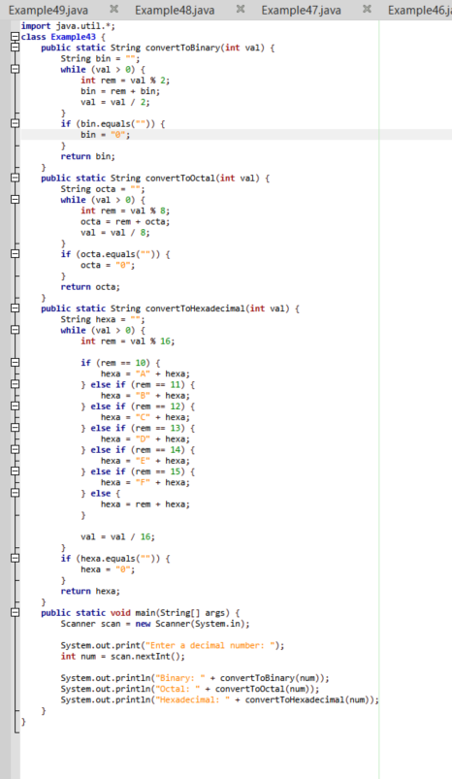
Output.
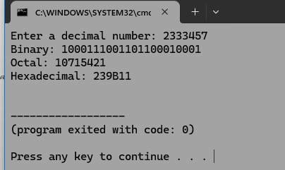

Q44.
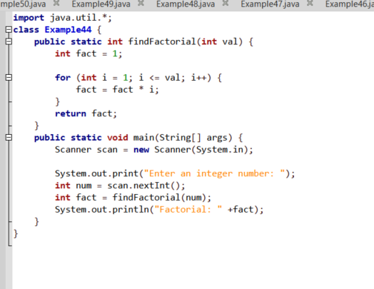

Output.
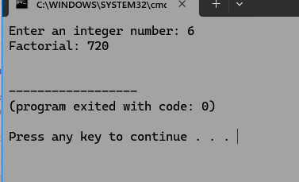

Q45.
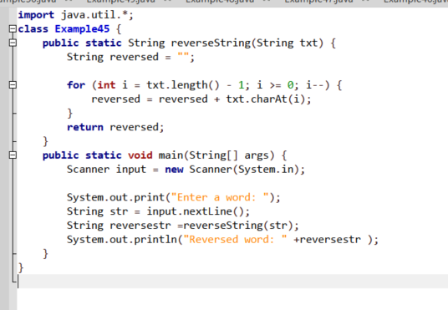
Output.
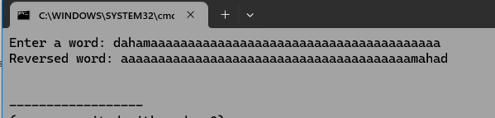

Q46.
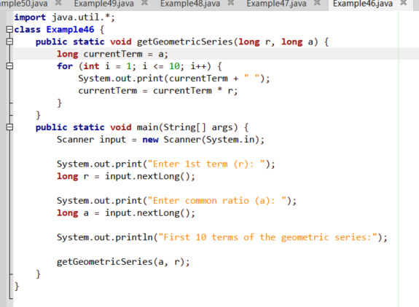
Output.
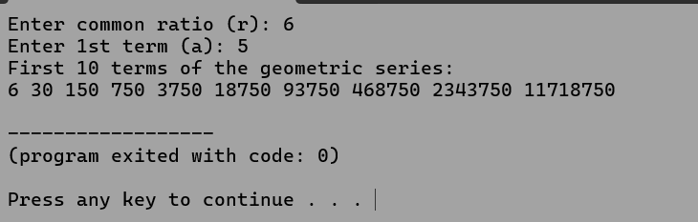

Q47.
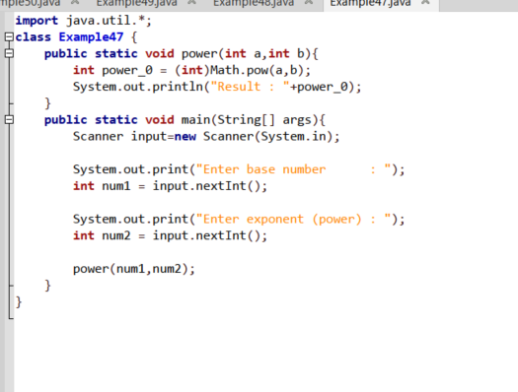
Output
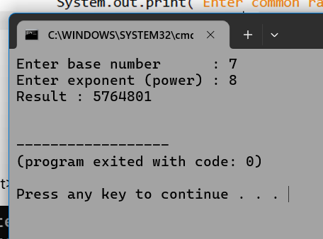

Q48.
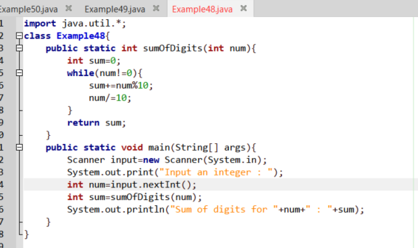
Output.
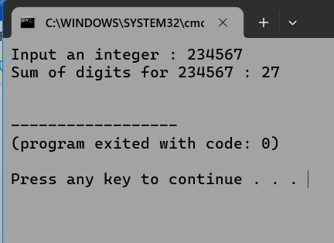

Q49.
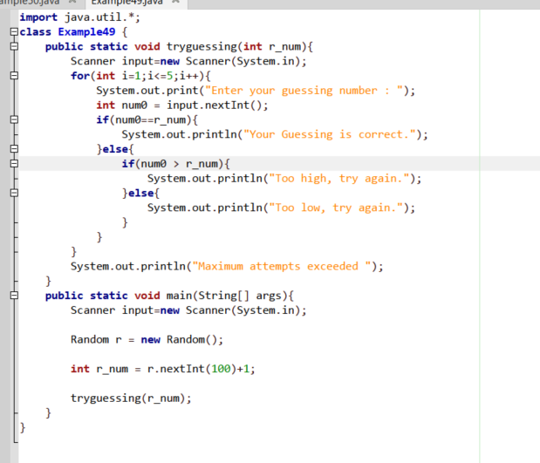
Output.
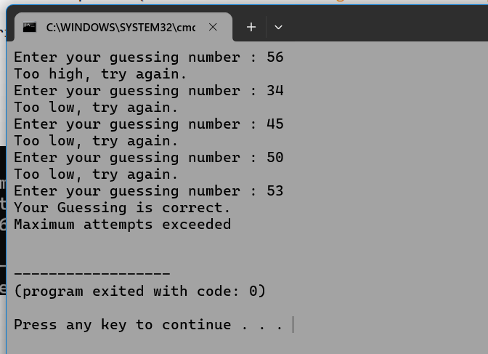
Q50.
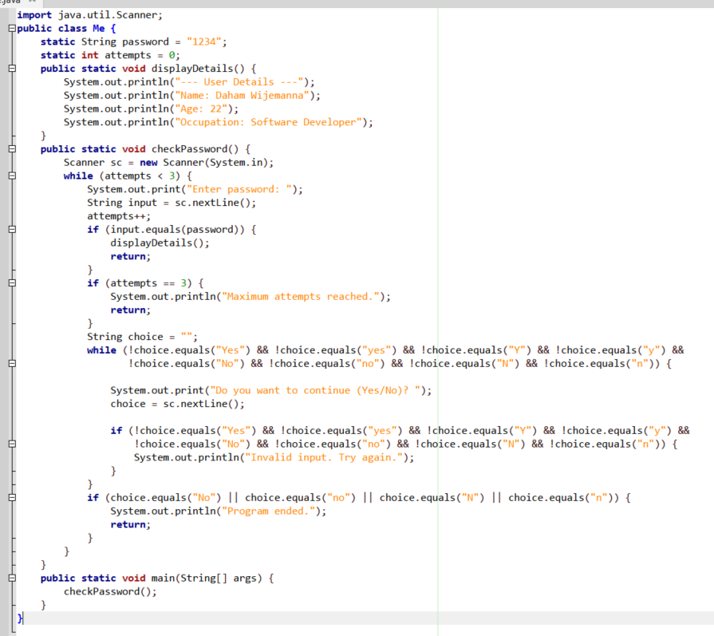
Output.
